**Version 1**

Model:

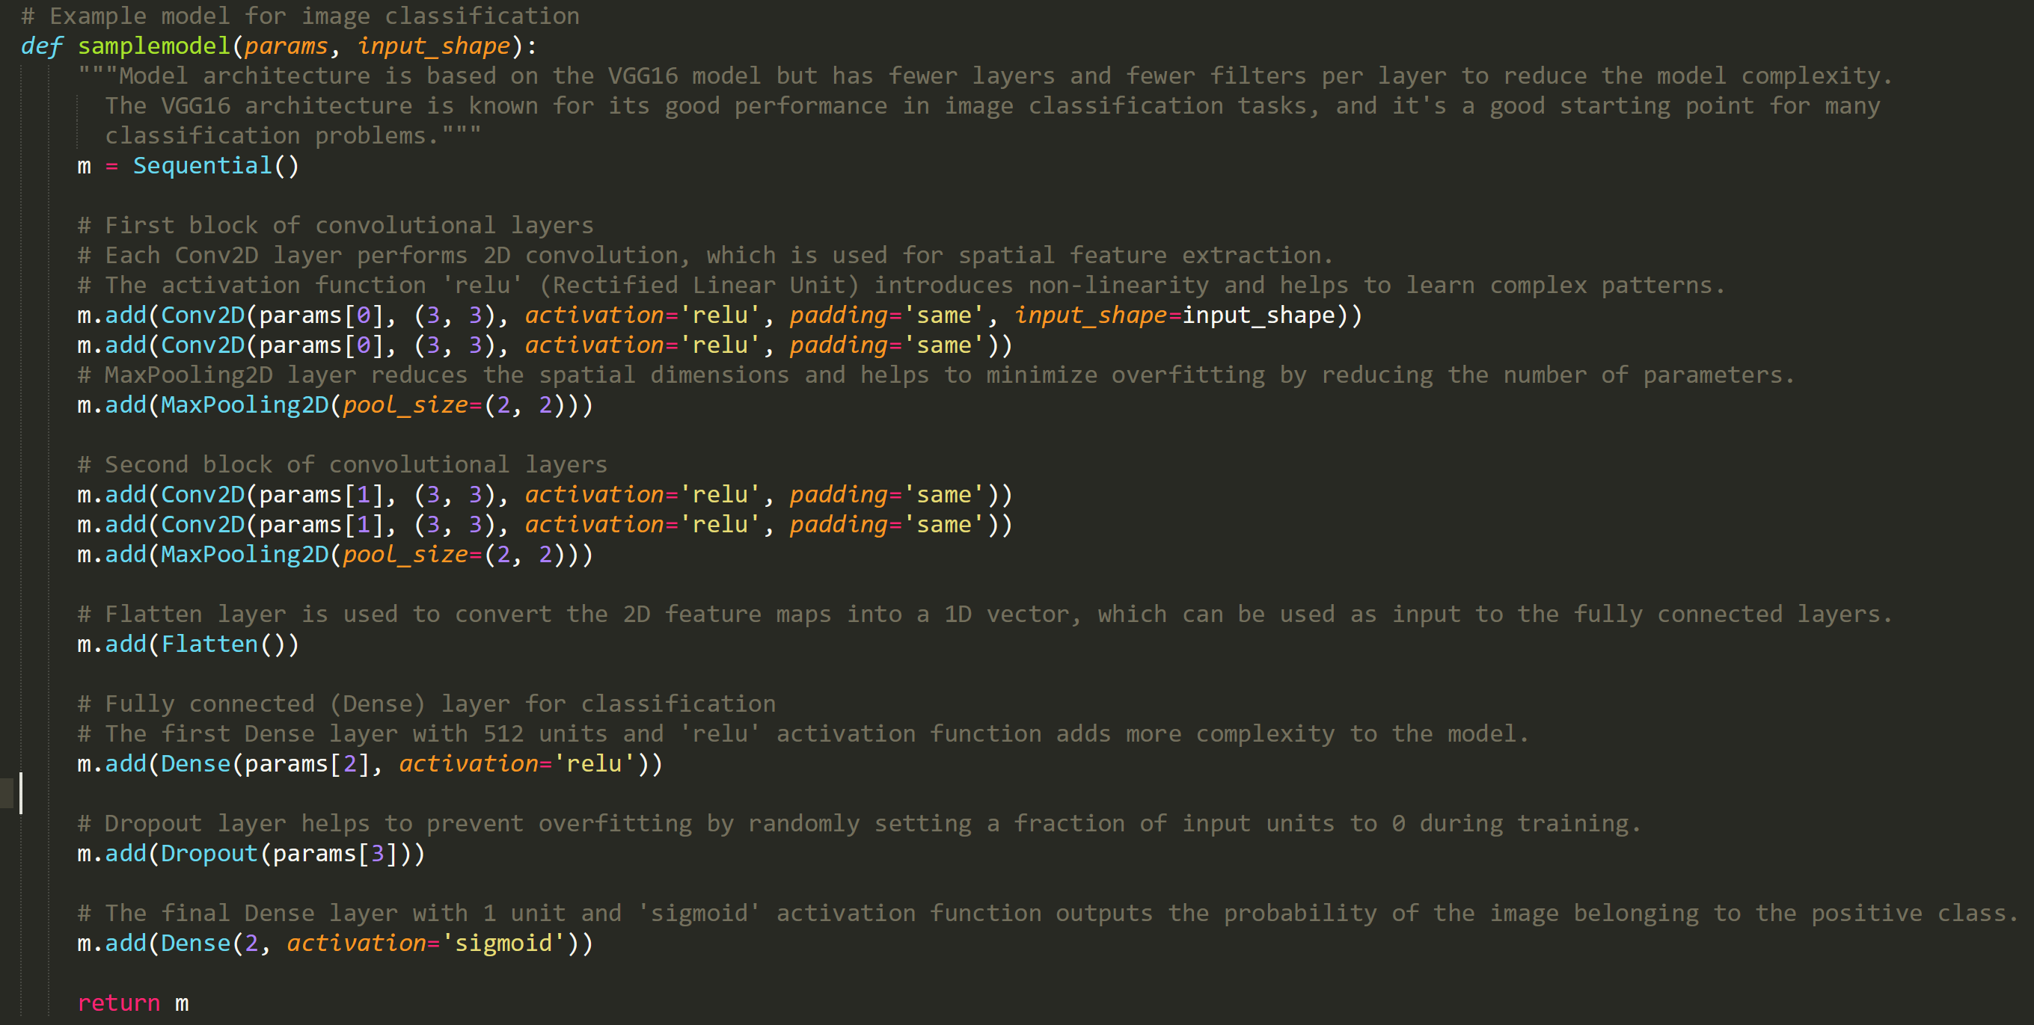

Parameters and Settings:

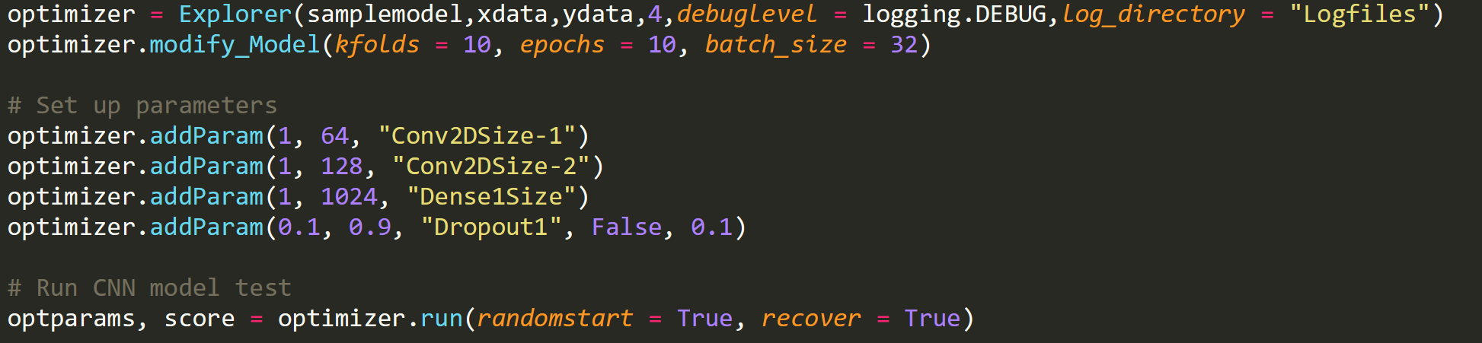

Discussion:

Based on how often we are shrinking the input layer to nearly nothing, I think our starting model is more complex than it needs to be. This model was suggested by GPT4 as a simplified image processing model, but I think we can go simpler. For the next version we will keep the same parameters but eliminate 1 layer from each of the two sets of convolutional layers and see how that performs. Might use this page for reference in future optimizations of model architecture: <https://medium.com/geekculture/introduction-to-neural-network-2f8b8221fbd3#:~:text=The%20number%20of%20hidden%20neurons,size%20of%20the%20input%20layer>.

Results:

03/27/2023 11:26:33 PM [INFO] Learning Curve Data:

03/27/2023 11:26:33 PM [INFO] Sample Sizes: 60 120 180 240 300 360 420 480 540 600

03/27/2023 11:26:33 PM [INFO] Train Scores: 0.74699 0.92562 0.00000 0.93600 0.70345 0.71345 0.72423 0.68347 0.67985 0.67403

03/27/2023 11:26:33 PM [INFO] Test Scores: 0.67565 0.76720 0.00000 0.75815 0.67553 0.67776 0.55333 0.67917 0.67519 0.67550

03/27/2023 11:26:33 PM [INFO] Validation Scores: 0.70968 0.76995 0.00000 0.80180 0.71197 0.71661 0.48235 0.70968 0.71197 0.70968

03/27/2023 11:26:33 PM [INFO] Final Parameters:

[26, 128, 676, 0.2]

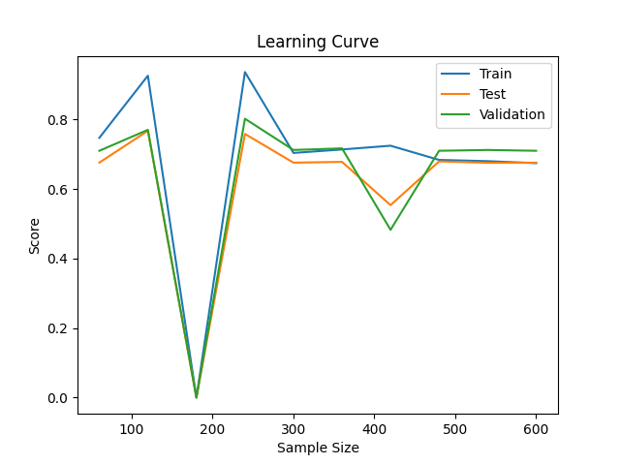

03/29/2023 11:15:19 PM [INFO] Learning Curve Data:

03/29/2023 11:15:19 PM [INFO] Sample Sizes: 60 120 180 240 300 360 420 480 540 600

03/29/2023 11:15:19 PM [INFO] Train Scores: 0.73171 0.94118 0.91979 0.94024 0.93333 0.91777 0.91469 0.75500 0.90943 0.77108

03/29/2023 11:15:19 PM [INFO] Test Scores: 0.66538 0.53979 0.68369 0.76973 0.67094 0.70183 0.69792 0.21875 0.44240 0.65823

03/29/2023 11:15:19 PM [INFO] Validation Scores: 0.70270 0.51064 0.71429 0.76923 0.67980 0.69672 0.70244 0.29630 0.57561 0.70588

03/29/2023 11:15:20 PM [INFO] Final Parameters:

[1, 94, 684, 0.2]

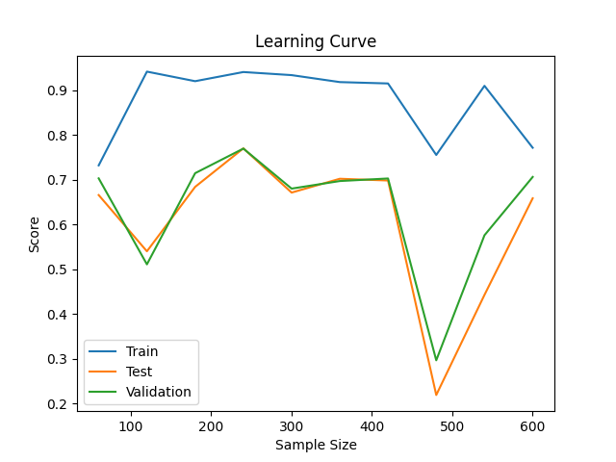

03/31/2023 10:43:00 PM [INFO] Learning Curve Data:

03/31/2023 10:43:00 PM [INFO] Sample Sizes: 60 120 180 240 300 360 420 480 540 600

03/31/2023 10:43:00 PM [INFO] Train Scores: 0.81579 0.83333 0.41379 0.83571 0.67550 0.71549 0.05381 0.67403 0.70886 0.67403

03/31/2023 10:43:00 PM [INFO] Test Scores: 0.73313 0.54971 0.18994 0.75410 0.67374 0.65618 0.04000 0.67495 0.64725 0.67550

03/31/2023 10:43:00 PM [INFO] Validation Scores: 0.75940 0.49057 0.19048 0.76305 0.70968 0.65421 0.05128 0.70968 0.74359 0.70968

03/31/2023 10:43:01 PM [INFO] Final Parameters:

[51, 77, 768, 0.8]

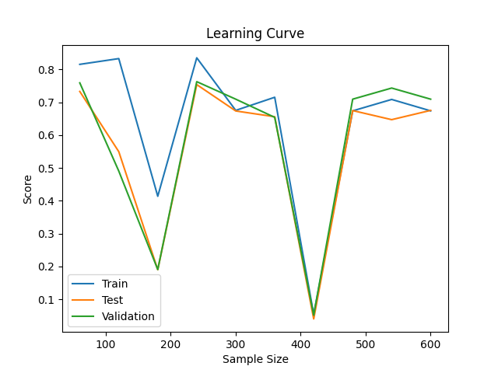

04/01/2023 07:20:59 PM [INFO] Learning Curve Data:

04/01/2023 07:20:59 PM [INFO] Sample Sizes: 60 120 180 240 300 360 420 480 540 600

04/01/2023 07:20:59 PM [INFO] Train Scores: 0.87879 0.87805 0.93122 0.91954 0.80139 0.78588 0.45517 0.80435 0.91473 0.06940

04/01/2023 07:20:59 PM [INFO] Test Scores: 0.74973 0.63733 0.72142 0.74207 0.62213 0.72560 0.22034 0.52318 0.45556 0.01905

04/01/2023 07:20:59 PM [INFO] Validation Scores: 0.78067 0.61386 0.71698 0.78030 0.56085 0.74510 0.16176 0.47568 0.44595 0.00000

04/01/2023 07:20:59 PM [INFO] Final Parameters:

[6, 104, 880, 0.30000000000000004]

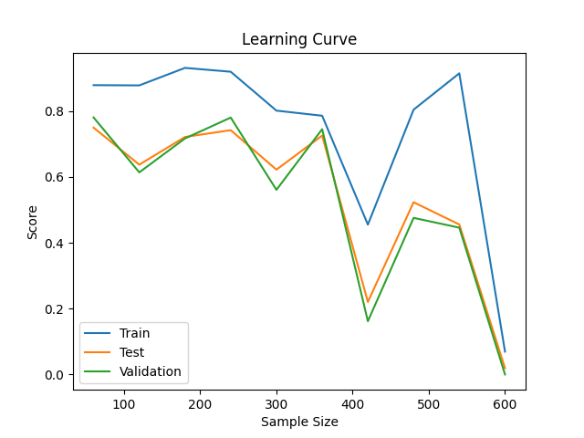

**Version 2**

Model:

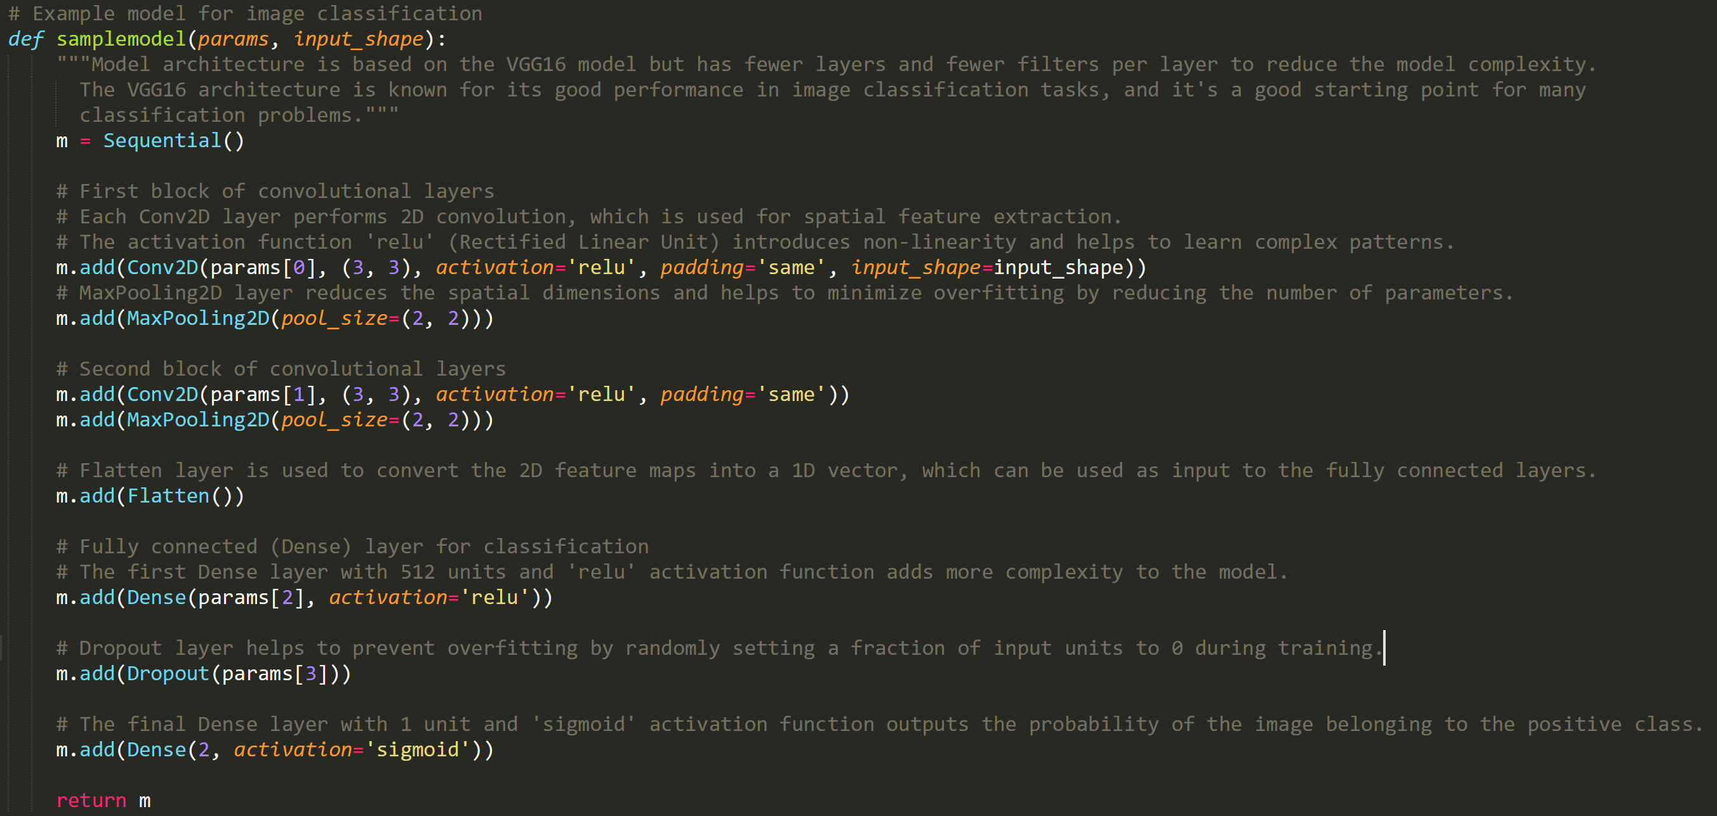

Parameters and Settings:



Discussion:

We appear to be a bit more consistent in our scores, especially at higher sample sizes which are more legitimate. All our tests show the Dense layer consistently in the upper half of the range so we’re going to change its min to 512 to halve the region. The first lay is still pretty small so we’re going to try eliminating the 2nd conv layer and increasing the size of the input layer to compensate. I’m tempted to remove the dropout which seems to only ever be 0.2 or 0.8, trending towards 0.8 but I think we’ll wait for now and if it is consistent we’ll drop it in the next version.

Results:

04/02/2023 06:41:47 AM [INFO] Learning Curve Data:

04/02/2023 06:41:47 AM [INFO] Sample Sizes: 60 120 180 240 300 360 420 480 540 600

04/02/2023 06:41:47 AM [INFO] Train Scores: 0.86207 0.92187 0.93478 0.93878 0.91195 0.86131 0.89151 0.83482 0.84310 0.88788

04/02/2023 06:41:47 AM [INFO] Test Scores: 0.46209 0.65718 0.73211 0.69396 0.71479 0.73022 0.66298 0.63604 0.41315 0.71429

04/02/2023 06:41:47 AM [INFO] Validation Scores: 0.34667 0.66942 0.68203 0.70000 0.74380 0.74717 0.61458 0.59783 0.47674 0.79051

04/02/2023 06:41:48 AM [INFO] Final Parameters:

[16, 73, 1024, 0.8]

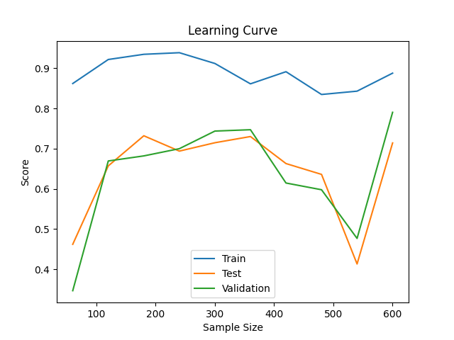

04/03/2023 10:54:44 PM [INFO] Learning Curve Data:

04/03/2023 10:54:44 PM [INFO] Sample Sizes: 60 120 180 240 300 360 420 480 540 600

04/03/2023 10:54:44 PM [INFO] Train Scores: 0.88235 0.93103 0.83721 0.91829 0.73253 0.80710 0.86066 0.87984 0.53425 0.83250

04/03/2023 10:54:44 PM [INFO] Test Scores: 0.70703 0.58935 0.55056 0.71157 0.71531 0.69551 0.74779 0.66261 0.33155 0.62887

04/03/2023 10:54:44 PM [INFO] Validation Scores: 0.70400 0.54217 0.44828 0.73810 0.74403 0.73759 0.75781 0.68807 0.49697 0.63158

04/03/2023 10:54:45 PM [INFO] Final Parameters:

[42, 80, 695, 0.7000000000000001]

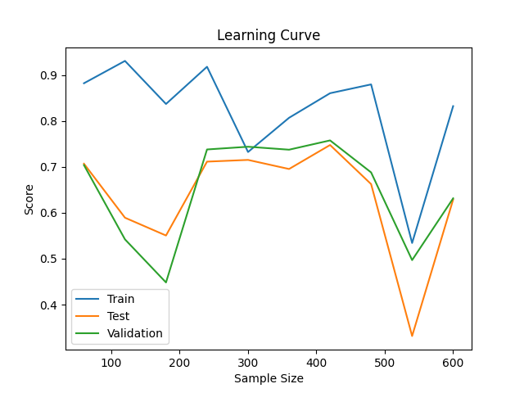

04/04/2023 10:40:26 AM [INFO] Learning Curve Data:

04/04/2023 10:40:26 AM [INFO] Sample Sizes: 60 120 180 240 300 360 420 480 540 600

04/04/2023 10:40:26 AM [INFO] Train Scores: 0.69663 0.53488 0.93617 0.92800 0.92013 0.90756 0.81704 0.93252 0.89189 0.84547

04/04/2023 10:40:26 AM [INFO] Test Scores: 0.67384 0.13720 0.74964 0.72794 0.73786 0.65641 0.50161 0.78287 0.65158 0.63218

04/04/2023 10:40:26 AM [INFO] Validation Scores: 0.70968 0.08547 0.74074 0.74074 0.76018 0.65969 0.50299 0.75926 0.66667 0.62032

04/04/2023 10:40:27 AM [INFO] Final Parameters:

[6, 116, 912, 0.8]

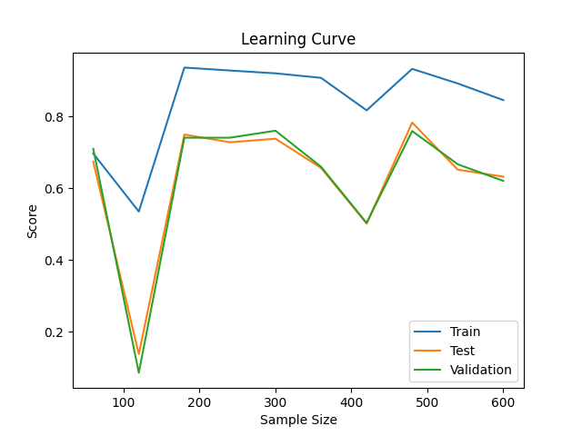

**Version 3**

Model:

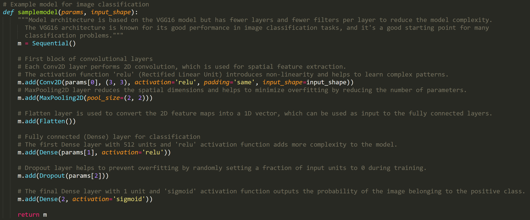

Parameters and Settings:

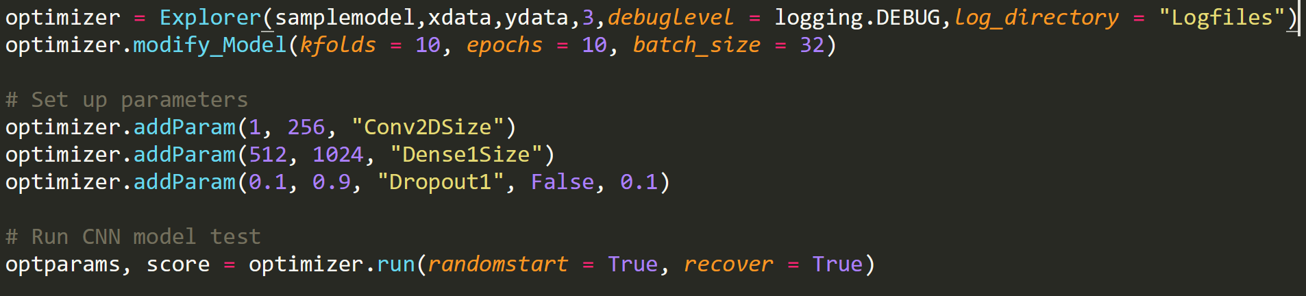

Discussion:

Still seeing a lot of inconsistency in learning curves. It is also very apparent that bigger layers are far less efficient than adding more layers. Dropout has been pretty consistent so we will set it constant. Dense layer has always been reasonably high. Will add another layer back in and bring the conv down to a smaller size, and also lower the range for the dense layer.

Results:

04/05/2023 04:04:21 AM [INFO] Learning Curve Data:

04/05/2023 04:04:21 AM [INFO] Sample Sizes: 60 120 180 240 300 360 420 480 540 600

04/05/2023 04:04:21 AM [INFO] Train Scores: 0.06250 0.88696 0.00000 0.20438 0.91216 0.92141 0.00000 0.10117 0.93407 0.66282

04/05/2023 04:04:21 AM [INFO] Test Scores: 0.00000 0.62827 0.00000 0.04795 0.63810 0.74059 0.00000 0.04762 0.69672 0.65766

04/05/2023 04:04:21 AM [INFO] Validation Scores: 0.00000 0.60000 0.00000 0.07018 0.65169 0.76577 0.00000 0.05263 0.71503 0.69672

04/05/2023 04:04:21 AM [INFO] Final Parameters:

[8, 992, 0.7000000000000001]

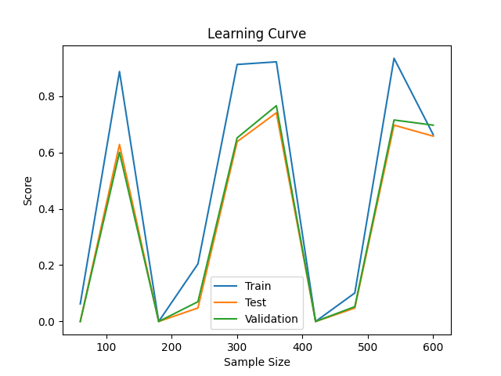

04/09/2023 06:02:13 AM [INFO] Learning Curve Data:

04/09/2023 06:02:13 AM [INFO] Sample Sizes: 60 120 180 240 300 360 420 480 540 600

04/09/2023 06:02:13 AM [INFO] Train Scores: 0.50000 0.73333 0.92778 0.80417 0.85000 0.90278 0.89286 0.91250 0.92593 0.86167

04/09/2023 06:02:13 AM [INFO] Test Scores: 0.49189 0.57941 0.73065 0.64107 0.70400 0.73864 0.76316 0.70312 0.70000 0.69000

04/09/2023 06:02:13 AM [INFO] Validation Scores: 0.45000 0.54000 0.67500 0.64500 0.67500 0.78000 0.70000 0.73000 0.65000 0.72500

04/09/2023 06:02:13 AM [INFO] Final Parameters:

[86, 820, 0.8]

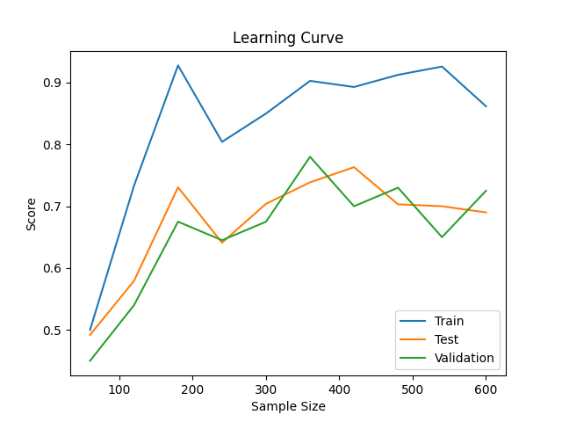

04/14/2023 01:23:17 AM [INFO] Learning Curve Data:

04/14/2023 01:23:17 AM [INFO] Sample Sizes: 60 120 180 240 300 360 420 480 540 600

04/14/2023 01:23:17 AM [INFO] Train Scores: 0.80000 0.87500 0.92222 0.93333 0.93000 0.70833 0.94762 0.75625 0.92778 0.92000

04/14/2023 01:23:17 AM [INFO] Test Scores: 0.61486 0.65147 0.69355 0.72679 0.70000 0.55455 0.76316 0.55312 0.74231 0.71500

04/14/2023 01:23:17 AM [INFO] Validation Scores: 0.60500 0.59000 0.62500 0.69500 0.70500 0.50500 0.72500 0.59000 0.75500 0.65000

04/14/2023 01:23:18 AM [INFO] Final Parameters:

[182, 1022, 0.6000000000000001]

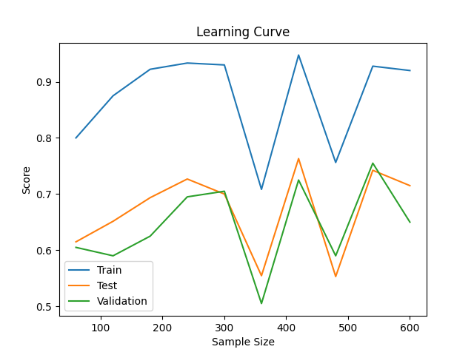

**Version 4**

Model:

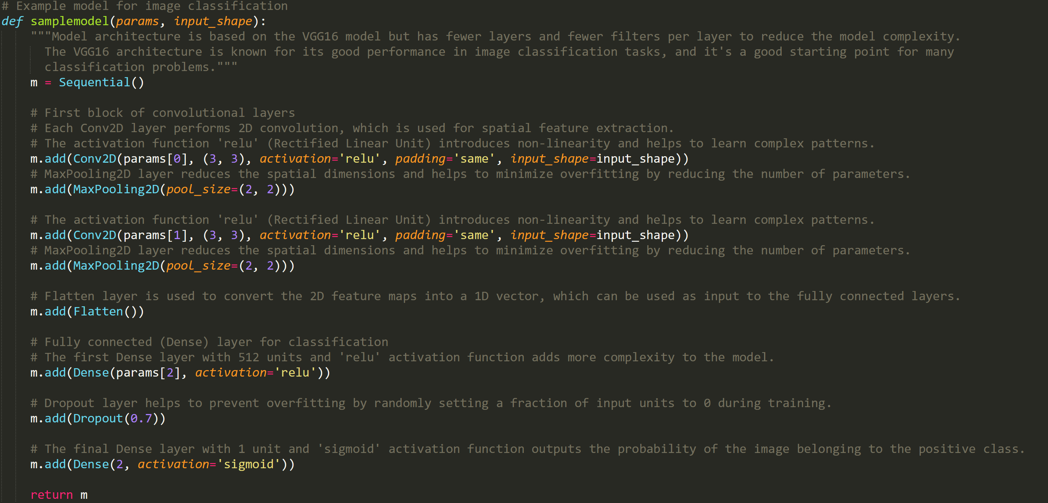

Parameters and Settings:

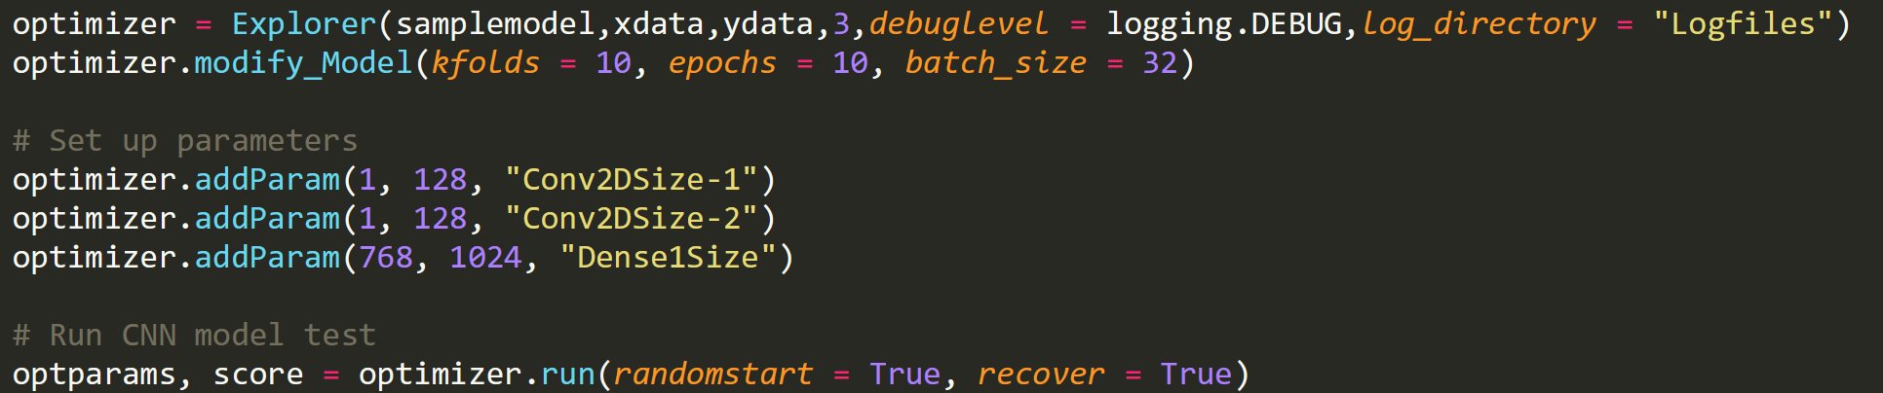

Discussion:

All these are just too inconsistent, this one is reasonably fast so I’m going to do a big pure learning curve run with a large sample size to see what we get. (100k completed twice in one night, with some decent time leftover)

Results:

04/15/2023 11:32:33 PM [INFO] Learning Curve Data:

04/15/2023 11:32:33 PM [INFO] Sample Sizes: 60 120 180 240 300 360 420 480 540 600

04/15/2023 11:32:33 PM [INFO] Train Scores: 0.61667 0.92500 0.85000 0.79167 0.51000 0.50833 0.89048 0.53542 0.66481 0.69000

04/15/2023 11:32:33 PM [INFO] Test Scores: 0.49189 0.57794 0.68387 0.63036 0.50800 0.50909 0.70789 0.50625 0.61154 0.57500

04/15/2023 11:32:33 PM [INFO] Validation Scores: 0.45000 0.60000 0.71000 0.65000 0.55000 0.55000 0.65500 0.56000 0.61500 0.57500

04/15/2023 11:32:33 PM [INFO] Final Parameters:

[128, 82, 848]

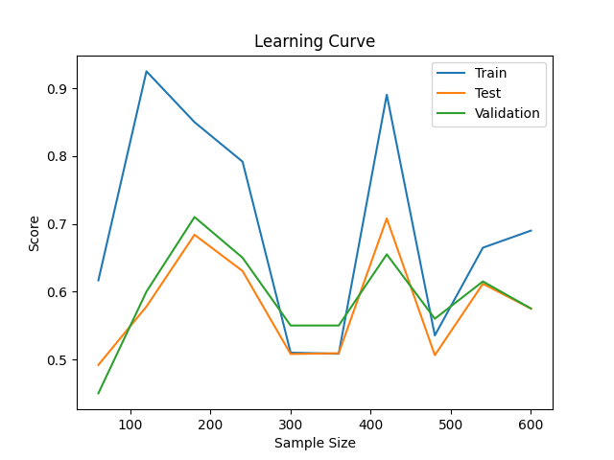

04/16/2023 08:22:17 PM [INFO] Learning Curve Data:

04/16/2023 08:22:17 PM [INFO] Sample Sizes: 60 120 180 240 300 360 420 480 540 600

04/16/2023 08:22:17 PM [INFO] Train Scores: 0.66667 0.88333 0.91111 0.92500 0.90000 0.66944 0.82143 0.85625 0.64815 0.64333

04/16/2023 08:22:17 PM [INFO] Test Scores: 0.51351 0.63235 0.67903 0.75179 0.67400 0.58864 0.61579 0.67812 0.60385 0.64000

04/16/2023 08:22:17 PM [INFO] Validation Scores: 0.55000 0.62500 0.64500 0.71000 0.62500 0.64000 0.63000 0.63500 0.66000 0.53000

04/16/2023 08:22:18 PM [INFO] Final Parameters:

[62, 67, 912]

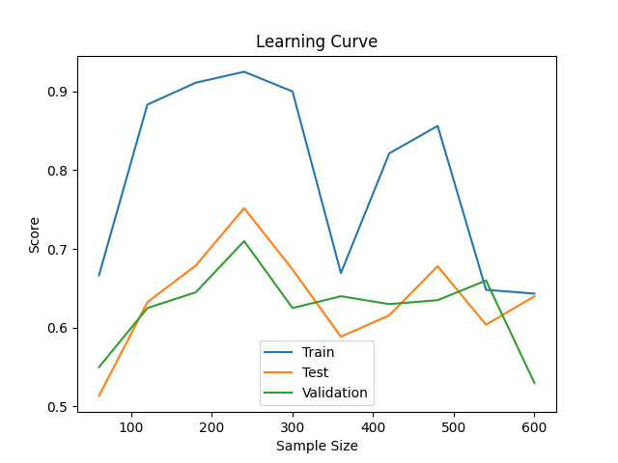

04/17/2023 07:14:11 AM [INFO] Learning Curve Data:

04/17/2023 07:14:11 AM [INFO] Sample Sizes: 60 120 180 240 300 360 420 480 540 600

04/17/2023 07:14:11 AM [INFO] Train Scores: 0.85000 0.91667 0.88333 0.89583 0.52667 0.77222 0.50952 0.51458 0.67222 0.56500

04/17/2023 07:14:11 AM [INFO] Test Scores: 0.64189 0.62794 0.72419 0.67857 0.50800 0.70227 0.50789 0.51250 0.63077 0.50000

04/17/2023 07:14:11 AM [INFO] Validation Scores: 0.60000 0.64000 0.69500 0.67500 0.55000 0.68000 0.55000 0.54000 0.65000 0.49500

04/17/2023 07:14:11 AM [INFO] Final Parameters:

[106, 84, 984]

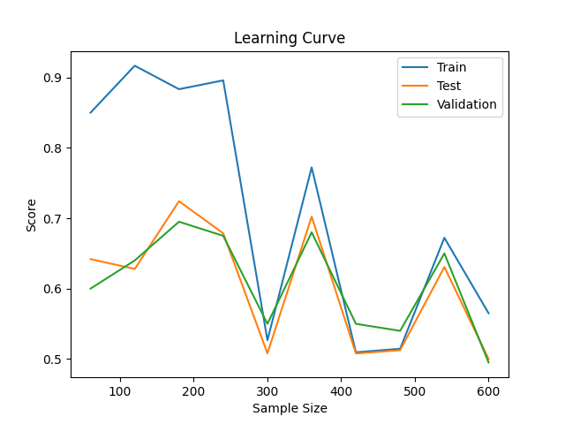

**Large Samples 1**

Model:



Parameters and Settings:

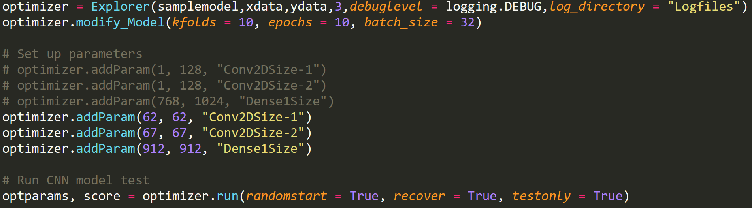

Discussion:

Seeing how good things look at bigger sample sizes. Only running learning curve with a preset parameter set. Noticing that the sample sizes are smaller than expected, 100k input samples is resulting in a curve maxing out at 20k samples for training. I think I might have found the issue, I believe we’ve hit the limit of the particular data fdile we’re reading from since they aren’t all merged. Looking back I think model 2 was a better base so we will move to that for next series.

Results:

04/17/2023 09:02:43 PM [INFO] Learning Curve Data:

04/17/2023 09:02:43 PM [INFO] Sample Sizes: 600 1200 1800 2400 3000 3600 4200 4800 5400 6000

04/17/2023 09:02:43 PM [INFO] Train Scores: 0.50500 0.68333 0.59167 0.65083 0.66433 0.66361 0.53690 0.56542 0.64148 0.50483

04/17/2023 09:02:43 PM [INFO] Test Scores: 0.50243 0.63676 0.55790 0.61179 0.62940 0.65159 0.53605 0.55625 0.62192 0.50050

04/17/2023 09:02:43 PM [INFO] Validation Scores: 0.49450 0.63300 0.58600 0.62600 0.62000 0.65200 0.52950 0.56300 0.63100 0.51100

04/17/2023 09:02:43 PM [INFO] Final Parameters:

[62, 67, 912]

04/17/2023 09:02:43 PM [INFO] Total runtime: 4289.940137147903

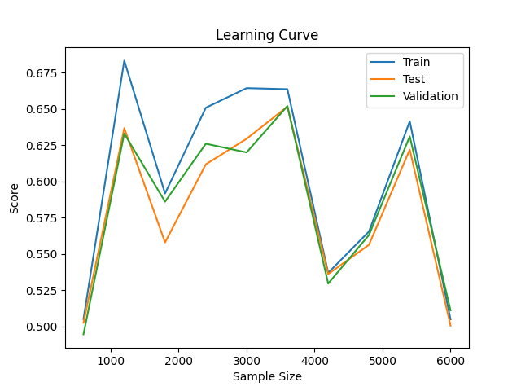

04/18/2023 01:11:07 AM [INFO] Learning Curve Data:

04/18/2023 01:11:07 AM [INFO] Sample Sizes: 1966 3932 5898 7864 9830 11796 13762 15728 17694 19660

04/18/2023 01:11:07 AM [INFO] Train Scores: 0.51119 0.51984 0.50627 0.66111 0.72981 0.55943 0.66974 0.61012 0.64886 0.67141

04/18/2023 01:11:07 AM [INFO] Test Scores: 0.50557 0.51252 0.50571 0.65341 0.72156 0.55618 0.67202 0.60843 0.65141 0.67501

04/18/2023 01:11:07 AM [INFO] Validation Scores: 0.50702 0.51129 0.50336 0.65578 0.71681 0.56408 0.67562 0.60497 0.63656 0.67897

04/18/2023 01:11:07 AM [INFO] Final Parameters:

[62, 67, 912]

04/18/2023 01:11:07 AM [INFO] Total runtime: 14750.852666854858

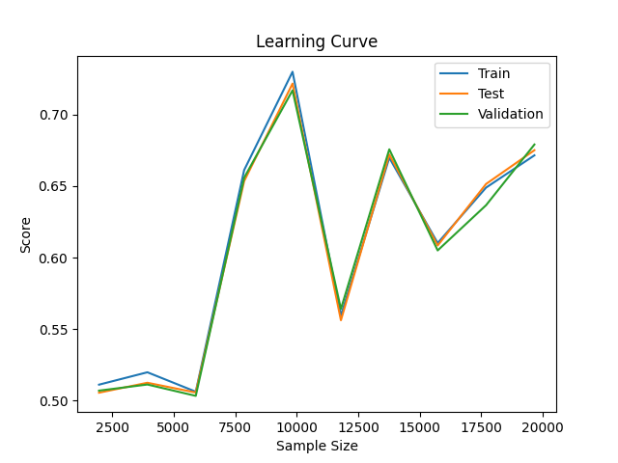

04/18/2023 05:09:05 AM [INFO] Learning Curve Data:

04/18/2023 05:09:05 AM [INFO] Sample Sizes: 1966 3932 5898 7864 9830 11796 13762 15728 17694 19660

04/18/2023 05:09:05 AM [INFO] Train Scores: 0.52136 0.63377 0.64446 0.62614 0.63978 0.55595 0.70426 0.64198 0.70849 0.64807

04/18/2023 05:09:05 AM [INFO] Test Scores: 0.51278 0.62252 0.62394 0.61586 0.62817 0.55875 0.70173 0.64152 0.69871 0.64602

04/18/2023 05:09:05 AM [INFO] Validation Scores: 0.51861 0.62328 0.63198 0.61932 0.62939 0.55462 0.69622 0.64144 0.70949 0.64602

04/18/2023 05:09:05 AM [INFO] Final Parameters:

[62, 67, 912]

04/18/2023 05:09:05 AM [INFO] Total runtime: 14271.93834900856

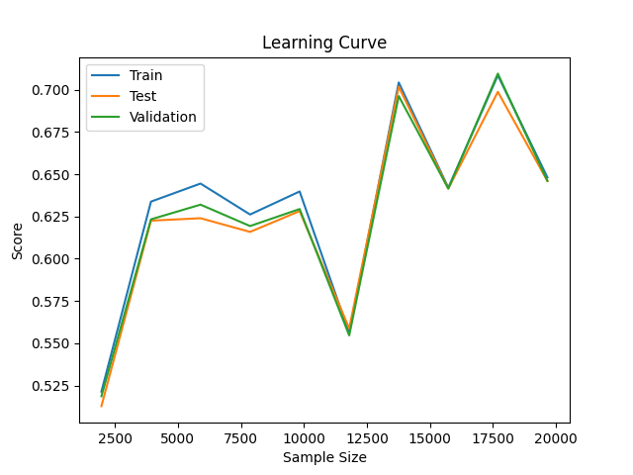

04/19/2023 12:32:03 AM [INFO] Learning Curve Data:

04/19/2023 12:32:03 AM [INFO] Sample Sizes: 1966 3932 5898 7864 9830 11796 13762 15728 17694 19660

04/19/2023 12:32:03 AM [INFO] Train Scores: 0.55799 0.67828 0.52340 0.56078 0.66470 0.73457 0.62963 0.64128 0.66802 0.70086

04/19/2023 12:32:03 AM [INFO] Test Scores: 0.53167 0.66103 0.51772 0.55711 0.66315 0.72500 0.62809 0.64696 0.67066 0.69393

04/19/2023 12:32:03 AM [INFO] Validation Scores: 0.53280 0.67241 0.51816 0.55584 0.66021 0.71971 0.63442 0.63854 0.66921 0.70095

04/19/2023 12:32:03 AM [INFO] Final Parameters:

[62, 67, 912]

04/19/2023 12:32:03 AM [INFO] Total runtime: 15182.540281057358

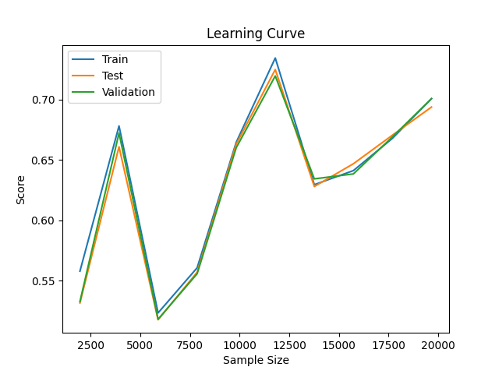

04/19/2023 04:44:32 AM [INFO] Learning Curve Data:

04/19/2023 04:44:32 AM [INFO] Sample Sizes: 1966 3932 5898 7864 9830 11796 13762 15728 17694 19660

04/19/2023 04:44:32 AM [INFO] Train Scores: 0.50407 0.49949 0.69091 0.65590 0.64975 0.64242 0.68217 0.68470 0.61066 0.64669

04/19/2023 04:44:32 AM [INFO] Test Scores: 0.50173 0.49928 0.65500 0.64921 0.64948 0.64579 0.68391 0.68396 0.59765 0.63488

04/19/2023 04:44:32 AM [INFO] Validation Scores: 0.50504 0.50183 0.65578 0.63473 0.65258 0.64922 0.68767 0.68309 0.60909 0.64358

04/19/2023 04:44:33 AM [INFO] Final Parameters:

[62, 67, 912]

04/19/2023 04:44:33 AM [INFO] Total runtime: 15143.437797546387

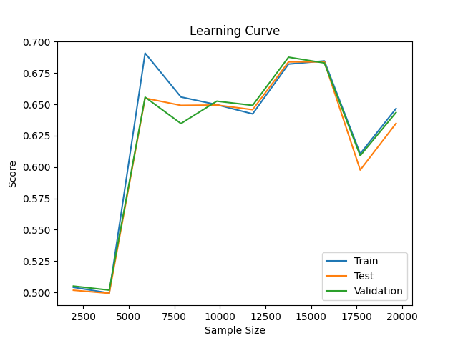

**Large Samples 2**

Model:



Parameters and Settings:

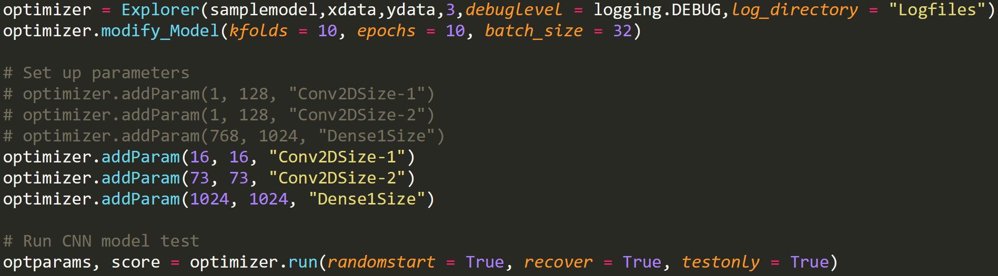

Discussion:

First run seemed to have more data that was input? 50k portion resulted in 70k samples at final point of curve. After some more detailed analysis, I think this is our best architecture, will repeat tuning process with higher sample size now that we’ve reduced the overall range of values to speed things up.

Results:

04/21/2023 09:30:04 AM [INFO] Learning Curve Data:

04/21/2023 09:30:04 AM [INFO] Sample Sizes: 6932 13864 20796 27728 34660 41592 48524 55456 62388 69321

04/21/2023 09:30:04 AM [INFO] Train Scores: 0.71437 0.70268 0.75976 0.72977 0.71304 0.74368 0.71573 0.67273 0.60444 0.74542

04/21/2023 09:30:04 AM [INFO] Test Scores: 0.67650 0.68064 0.72796 0.72241 0.70118 0.73723 0.70836 0.66596 0.60136 0.74181

04/21/2023 09:30:04 AM [INFO] Validation Scores: 0.67665 0.68154 0.72399 0.72114 0.70409 0.73299 0.71097 0.66462 0.59997 0.74476

04/21/2023 09:30:05 AM [INFO] Final Parameters:

[16, 73, 1024]

04/21/2023 09:30:05 AM [INFO] Total runtime: 42062.12475156784

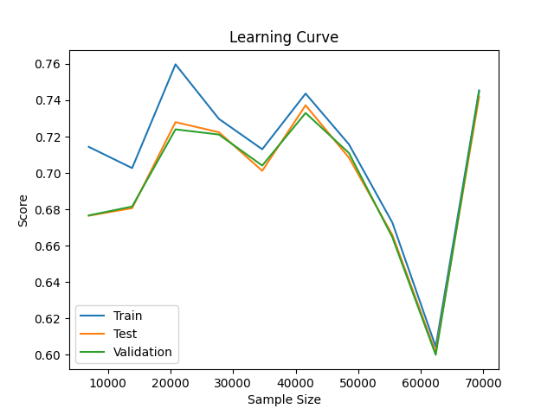

04/22/2023 08:38:07 AM [INFO] Learning Curve Data:

04/22/2023 08:38:07 AM [INFO] Sample Sizes: 6332 12664 18996 25328 31660 37992 44324 50656 56988 63321

04/22/2023 08:38:07 AM [INFO] Train Scores: 0.66961 0.74597 0.64224 0.74601 0.71545 0.68264 0.73913 0.72783 0.75265 0.67290

04/22/2023 08:38:07 AM [INFO] Test Scores: 0.62424 0.68654 0.63313 0.72212 0.70759 0.67573 0.72973 0.71382 0.74155 0.66656

04/22/2023 08:38:07 AM [INFO] Validation Scores: 0.62891 0.68652 0.62810 0.72655 0.70651 0.67614 0.72868 0.71897 0.75085 0.66932

04/22/2023 08:38:07 AM [INFO] Final Parameters:

[16, 73, 1024]

04/22/2023 08:38:07 AM [INFO] Total runtime: 37966.4130923748

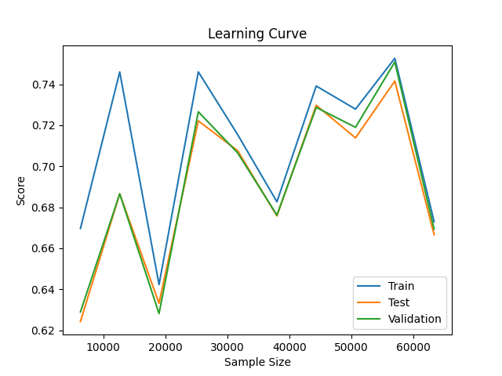

**Version 5**

Model:

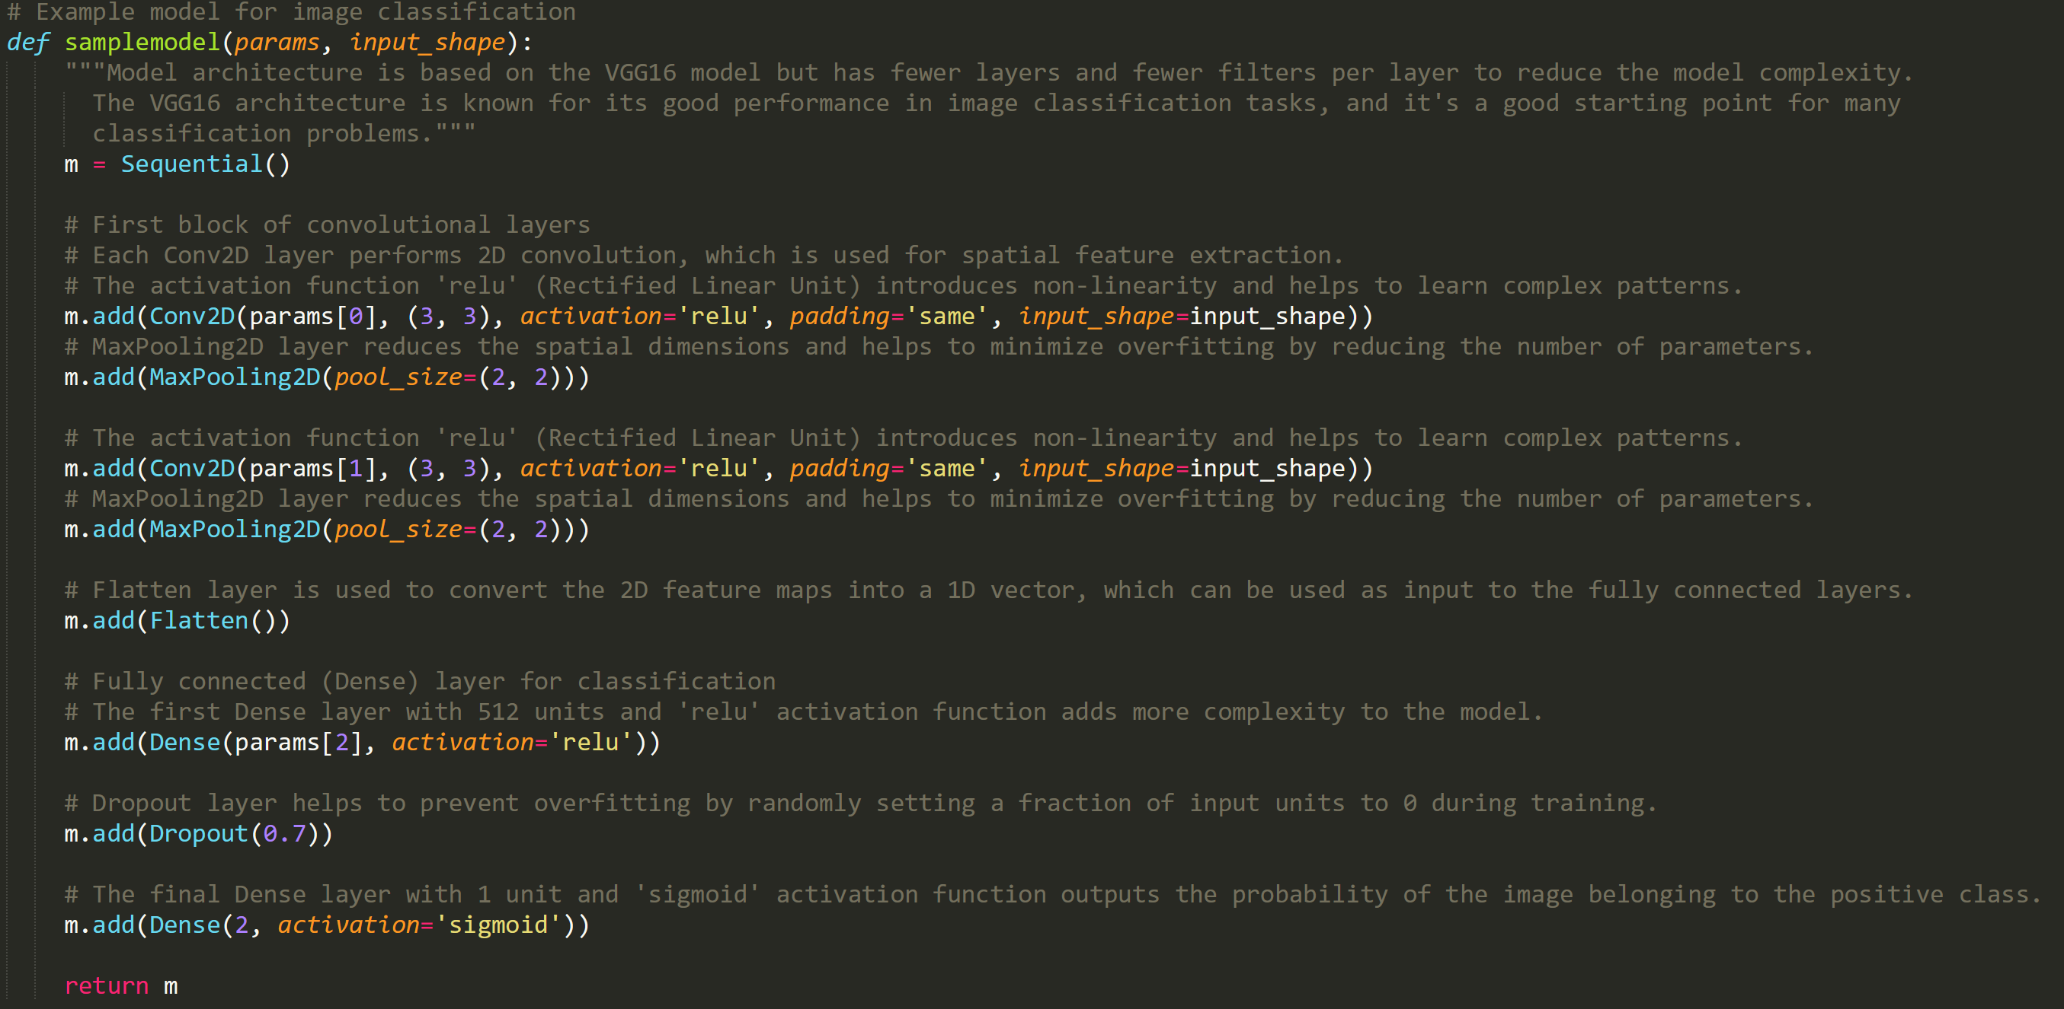

Parameters and Settings:

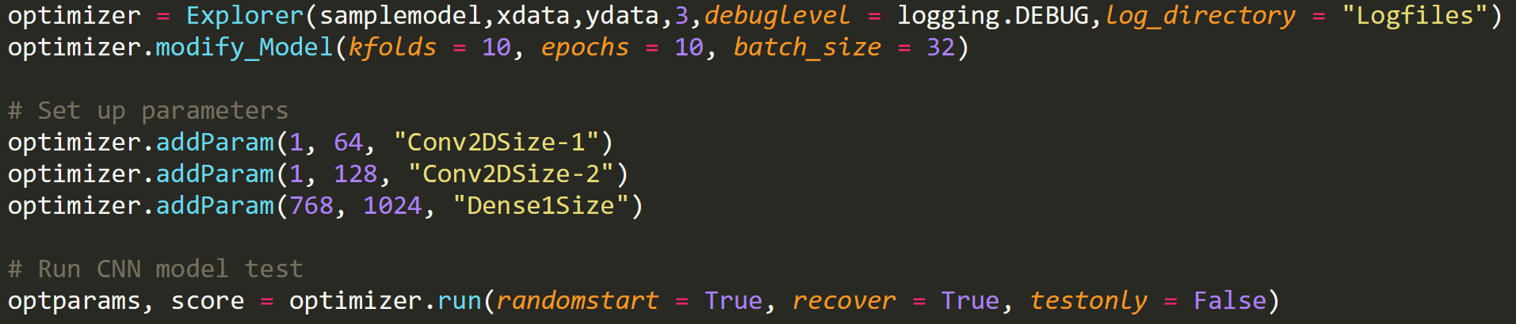

Discussion:

Returning to model version 2 with a narrower range of potential values. Will be using a much larger sample size (about 10x to start) for final evaluation. First few cycles were at 10k portion, lowered to 5k after a whole night only got through 2 search steps

05/03/2023 05:00:02 AM [INFO] Learning Curve Data:

05/03/2023 05:00:02 AM [INFO] Sample Sizes: 810 1620 2430 3240 4050 4860 5670 6480 7290 8100

05/03/2023 05:00:02 AM [INFO] Train Scores: 0.91728 0.59877 0.87654 0.79969 0.68691 0.77243 0.80670 0.43503 0.74719 0.77556

05/03/2023 05:00:02 AM [INFO] Test Scores: 0.70771 0.53671 0.71123 0.67844 0.64785 0.69529 0.74737 0.42269 0.68519 0.68593

05/03/2023 05:00:02 AM [INFO] Validation Scores: 0.69370 0.54185 0.70926 0.67963 0.65667 0.69519 0.73704 0.41259 0.67333 0.67741

05/03/2023 05:00:03 AM [INFO] Final Parameters:

[18, 128, 976]

05/03/2023 05:00:03 AM [INFO] Total runtime: 35901.113402843475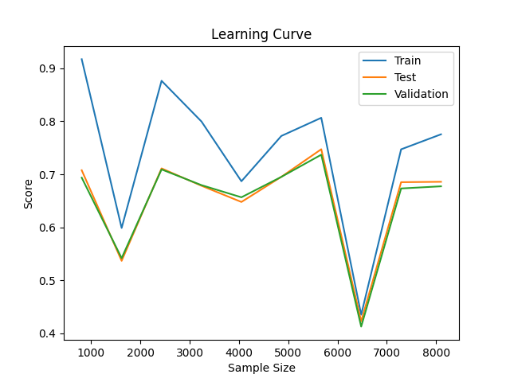

**Final**

Using the above parameters, the model was evaluated with a large data set

05/04/2023 03:57:24 AM [INFO] Learning Curve Data:

05/04/2023 03:57:24 AM [INFO] Sample Sizes: 9932 19864 29796 39728 49660 59592 69524 79456 89388 99321

05/04/2023 03:57:24 AM [INFO] Train Scores: 0.79199 0.75247 0.65901 0.72725 0.72946 0.79477 0.69767 0.63756 0.69321 0.69163

05/04/2023 03:57:24 AM [INFO] Test Scores: 0.72800 0.72022 0.65029 0.71896 0.72181 0.78344 0.69624 0.63332 0.68878 0.68538

05/04/2023 03:57:24 AM [INFO] Validation Scores: 0.72674 0.72348 0.64779 0.71777 0.72146 0.78265 0.69391 0.63380 0.69062 0.68766

05/04/2023 03:57:24 AM [INFO] Final Parameters:

[18, 128, 976]

